March 2008 Newsletter
COMMANDER. Stephen Hansen Phone 717 762 0323 CHAPLAIN. Alan R. Shane Phone 301 223 7106
SR. VICE COMDR. Tony Pruchniewski 301 739 7911 Visitation CHAPLAIN. Bob Blair Phone 301 790 2189
JR. VICE COMDR. Patrick Casey 978 433 6727 SGT. AT ARMS. Clyde Stair
ADJUTANT. Ernie Unger Phone 301 842 2562 O.D. Ted Dundus
TREASURER. Howard L. Williams, Jr. JUDGE ADVOCATE. Robert Sandberg
DAV Chapter Web Site: www.davmembersportal.org/chapters/md/14
Chapter Web Site; www.geocities.com/hagerstownDAV

MEETING NOTICE
The next Chapter Meeting will be held at 7:00 PM March 18th at the Funkstown American Legion Post 211. Chapter meetings are held on the third Tuesday of each month beginning at 7:00 PM. Refreshments are served after the Chapter Meeting.
A Chapter Executive Committee Meeting will be held March 13th at 9:00 AM. The Chapter Executive Committee Meetings are held at Post 202 American Legion, American Legion Drive, Williamsport, Maryland. The Executive Committee Members get together at 8:00 AM for Breakfast prior to the meeting any member may attend.

KITTY DRAWINGS
The following Members names were drawn at last months meeting on the Kitty Drawings.
Prize #1 - $100.00 = Patrica A. Breeden (Not Present)
Prize #2 - $44.00 = Michael C. Morris (Not Present)
Kitty Drawings are held at each regular meeting. The purpose of these drawings is to increase attendance. You must be present and have donated $.50 prior to each drawing to be eligible to win.

COMMANDER
Comrades; I would like to welcome our new Chapter #14 members; I know that you will be a value asset to our DAV Chapter. Please attend our meetings and become involved in Chapter activities and programs I look forward to seeing each of you. Also the Chapter Executive committee meeting are open to all members, (time and place is listed above) please join us.
We must all act as recruiters for our Chapter, and continue to search for new members everywhere we go. Our Chapter offers each new member an extremely aggressive, productive and talented group of members with vision and a view to the future.
Nominations for Chapter Officers will be reopened this month, if you wish to become an officer of Chapter #14 please let your wishes be known at the meeting.
Remember, our installation dinner will be held on April 15th, 2008 at the Funkstown American Legion beginning at 6:00 PM. Get your reservation in now for the dinner the cutoff date for reservations is April 8th.
Thank you for allowing me to serve as the Commander of Chapter #14. As always, should you desire to attend our meetings and require a ride, please call me at home (717) 762-0323 or on my cell phone (717)404-6580 or at shansen.dav@comcast.net. Respectfully, Steve Hansen, Commander

CHAPLAIN
We have lost two members of Chapter #14 during February, Robert E."Birdie" Billman and George R "Bob" Ebersole and on behalf of the officers and members of the chapter extend sincere sympathy to both families Many remember the years of music "Birdie" brought to our Chapter Picnics. Comrades, we will miss you.
Please keep Ora Delauter, Wilbur Mitchell, Fred Wisherd, Wayne Alter, Wayne French, Joe Dyer, Dale Everett, Stanley Jones, James Paff, Richard Robinson, Basil Kuhn and Clarence Schroyer in your prayers and call Chaplain Blair or me if you are aware of any others. You also might take a few minutes to make contact with someone who is not able to be with us. Should you be aware of anyone else that we should note please call Bob or me. Chaplain Blair and I will keep all of you in our prayers so go in peace and respect one another. In His Service, Alan Shane, Chaplain
INSTALLATION DINNER
The date of the dinner will be April 15, 2008. The evening will begin with a Cash Bar beginning at 6:00 PM. Dinner will be served at 7:00 PM. The Menu will be Roast Beef, Fried Chicken, Mashed Potatoes, Succotash, Cole Slaw, Rolls, Butter and Pie for dessert. The Cost will be $10.00 for each Chapter Member or their Guest. This function is by Reservation Only! Reservations can be made by returning the form below with payment of $10.00 for each Member or Guest, payable to DAV Chapter 14. Please return your reservation to: DAV Chapter 14, C/o Ernest C. Unger, Adjutant, 11837 Hanging Rock Road, Clear Spring, MD. 21722-1058. April 8th is the last day Reservations can be accepted.

NAME _______________________

Total Members & Guests _________ Amount enclosed $____________

Disabled American Veterans
NON-PROFIT ORG.
U. S. POSTAGE

P A I D
Clear Spring, MD.
Permit No. 18
Ralph S. Tagg, Jr., Chapter 14
C/o Ernest C. Unger
11837 Hanging Rock Rd.
Clear Spring, MD. 21722

This Month’s information covers 2 subjects “VA Readjustment Counseling Services & Travel Costs”
VA provides readjustment counseling services through 207 community-based Vet Centers located in 50 states, the District of Columbia, Guam, Puerto Rico and the Virgin Islands. Counseling is designed to help combat veterans readjust to civilian life.
Eligibility: Veterans are eligible if they served on active duty in a combat theater during WW II, the Korean War, the Vietnam War, the Gulf War, or campaigns in Lebanon, Grenada, Panama, Somalia, Bosnia, Kosovo, Afghanistan, Iraq and the Global War on Terror. Veterans, who served in the active military during Vietnam Era, but not in the Republic of Vietnam, must have requested services from a Vet Center before Jan. 1, 2004.
Services Offered: Vet Center staff provides individual, group, family, military sexual trauma, and bereavement counseling. Services include treatment for post-traumatic stress disorder (PTSD) or help with any other military related issue that affects functioning within the family, work, school or other areas of everyday life. Other services include outreach, education, medical referral, homeless veteran services, employment, VA benefit referral and the brokering of non-VA services.
Bereavement Counseling: Bereavement counseling is available to all family members include spouses, children, parents and siblings of service members who die while on active duty. This includes federally activated members of the National Guard and reserve components. Bereavement services may be accessed by calling (202) 273-9116 or e-mail vet.center@va.gov/.
VA Travel Reimbursement Rates, Deductibles Increase
Effective Feb. 1, 2008 the Department of Veterans Affairs Beneficiary Travel Program mileage reimbursement rate increases from 11 cents per mile to 28.5 cents per mile for travel to or from a VA facility or other place of examination, treatment or care. Along with the increase in reimbursement rates, the VA increased associated deductibles. The new deductibles are $7.77 per one way trip and $15.54 for a round trip, with a maximum deductable of $46.62 per calendar month. These deductibles may be waived when their imposition would cause severe financial hardship, the VA said
Eligibility: Payments may be made to the following.
- Veterans whose service-connected disabilities are rated 30 percent or more.
- Veterans traveling for treatment of a service connected condition.
- Veterans who receive a VA pension.
- Veterans traveling for scheduled compensation or pension exams.
- Veterans whose gross household income does not exceed the maximum annual VA pension.
- Veterans whose medical condition requires a special mode of transportation, if they are unable to defray the costs and travel is pre-authorized. Advance authorization is not required in an emergency if a delay. Ernie Unger, Editor/CSO
For additional information on the above or other information related to your specific VA entitlements please contact the Chapter Service Officer at (301) 842 2562. Or one of the Service Officers below.
DAV National Service Officer, Baltimore Office Phone Number (410) 230 4440.
The Maryland Veterans Commission Office is located at 33 west Washington St. Room 206, Hagerstown. Service Officer Mr. George E. Kauffman hours are Tuesday’s from 9:00 AM until 2:00 PM. Phone (301) 791 0356.
Franklin County Pennsylvania, Veterans Representative Robert Harris Phone (717) 263 4326
Adams County Pennsylvania, Veterans Representative, Mark Stock, Phone (717) 337 9835

This Month’s information covers “VA’s Special Access to
Service Disabled Veterans: Veterans who are 50

The Hagerstown VA Outpatient Clinic is located at

[Type a quote from the document or the summary of an interesting
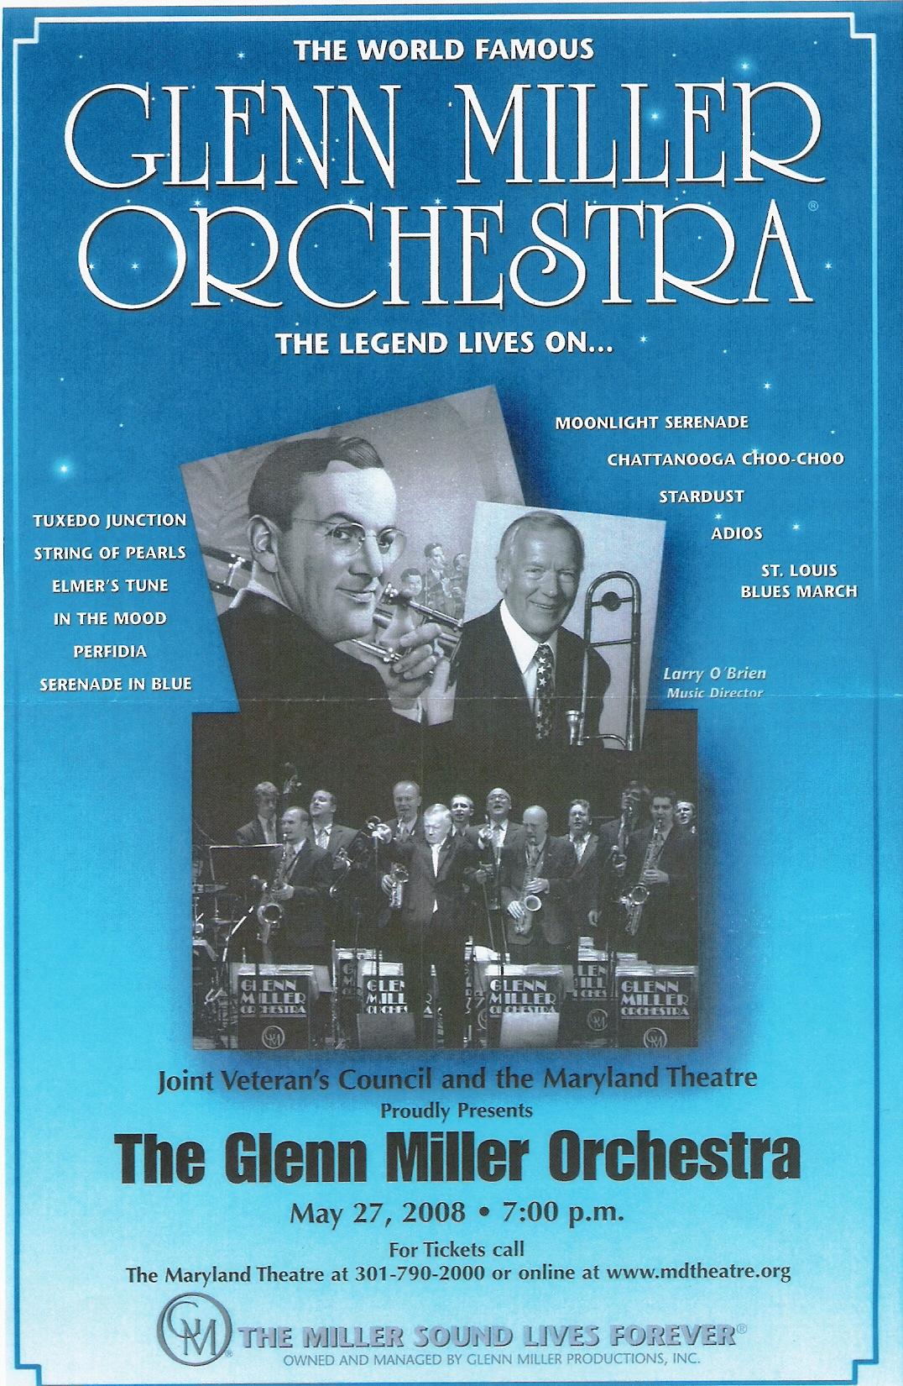
The Hagerstown VA Outpatient Clinic is located at the Hub Plaza on Eastern Blvd., Hagerstown. Hours of operation are Monday thru Friday; 8:00 AM until 4:00 PM., Phone 1-866-399-0117 or (301) 665-1462
And Finally: “An individual has not started living until he can rise above the narrow confines of his individualistic concerns to the broader concerns of all humanity.” - Martin Luther King, Jr. -

